1. Open ShopPAK  
   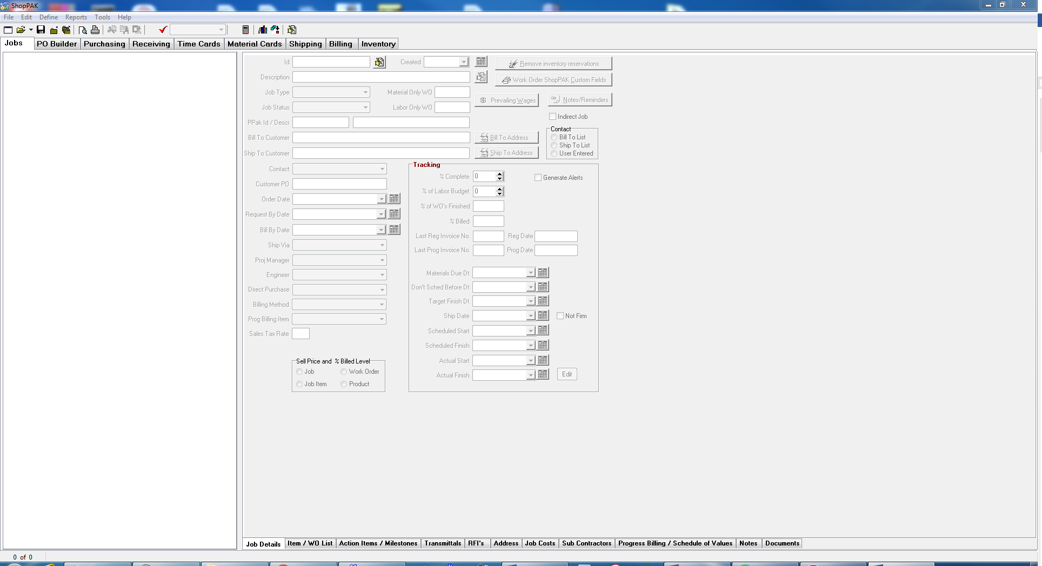
2. Open Job that needs to have Milestone Dates Assigned  
   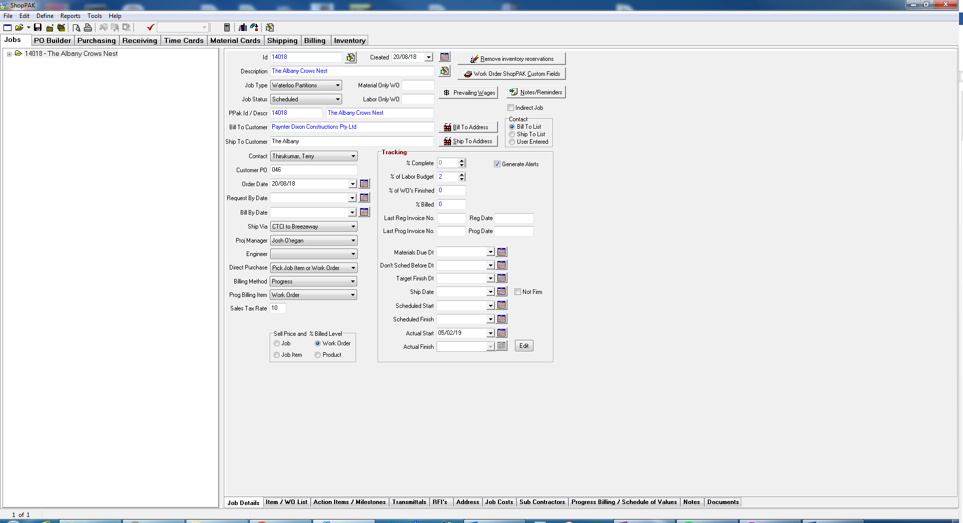
3. Open Action Items / Milestones tab  
   
4. Ensure that the milestones have been selected at the Work Order level.  
   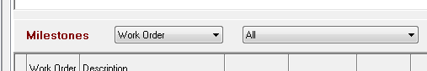
5. In this example the customer delayed returning drawings 3 days past the normal time, ie. They were received on the 7th, should have been on the 4th.   
   Dates do not need to be updated before drawings are returned, this will ensure that these Work Orders will be flagged in Scoreboard.  
   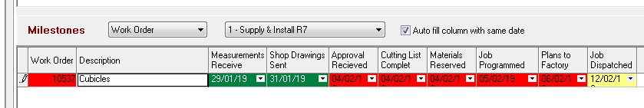
6. Set the Completed date for the Approval Received, in this example it is the 7th   
   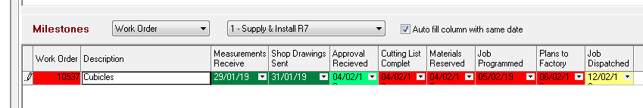
7. Right click in the Milestone Grid  
   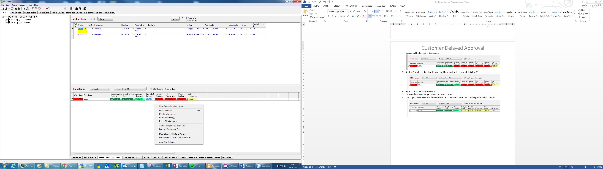
8. Click on the Mass Change Milestone Dates option  
   
9. Select the Work Orders that need their Milestones updated  
   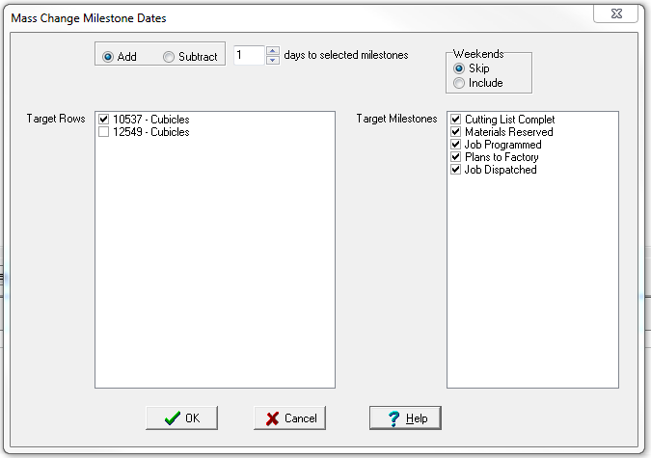
10. Set the number of days the approval was delayed by, in this example it is 3 days  
    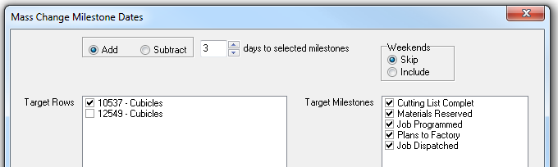
11. Click OK to add the extra days to the outstanding Milestones

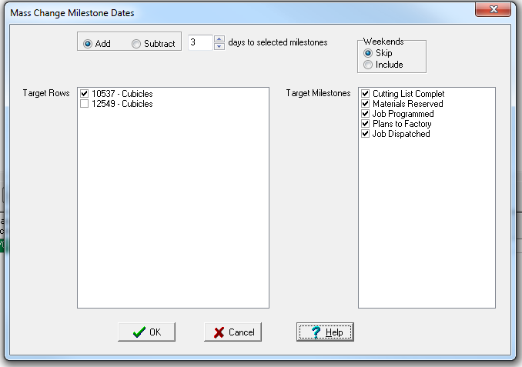

1. The target dates have now been updated and the Work Order can now be processed further as normal.  
   